North America Meets Europe
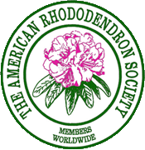
The 2018 ARS Convention will be in Bremen, Germany. It will start around May 7, 2018, with optional tours before the convention and after the convention. The schedule may and probably will change slightly in the next couple months.
- 1st Pre-Tour: Optional 5 days visiting Dutch Gardens including Keukenhof Gardens
- 2nd Pre-Tour: Optional 2 days at RHODO 2018 Rhododendron Festival and Bremen
- 3rd Pre-Tour: Optional 6 days public and private garden visits in Denmark & Sweden
- Convention: 7-day convention in Bremen from May 20 to 26 including 3 tour days
- Post-Tour: Optional 4 days visiting gardens in Finland.
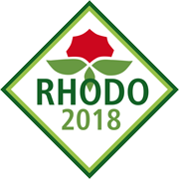
Calendar this now! It is a do-not-miss event. You can choose to start in Holland or Germany with one of the 3 pre-tours or start with the convention. Then you can choose to finish in Germany after the convention or in Finland after the post-convention tour. There are 8 possible combinations ranging from 7 days & nights for just the convention to 24 days & nights if you do everything which includes the 3 pre-tours to Holland, Germany, Denmark and Sweden; the convention; and the post-convention tour to Finland.

